 |  | RCSJTA TT BB CR_002  Capability API
Meeting Information
Meeting Name and Number
Meeting Date
Meeting Location |  | Conference Call
Document Information
Document Author(s) |  | Jean-Marc AUFFRET, Orange Labs
Document Creation Date |  | 02/08/2013
 |  | Approval | X
This document is for: (mark X as appropriate) |  | Discussion
 |  | Information only
Security Classification – Non Confidential / Confidential GSMA Material (Delete as appropriate and delete the rows below that do not apply) |  |  | Can be distributed to: (mark X as appropriate or specify group
Non Confidential |  | Public
Confidential |  | Project Team or Group | X
Confidential |  | GSMA HQ Staff | X
Confidential |  | GSMA Full Members | X
Confidential |  | GSMA Associate Members | X
Confidential |  | GSMA Rapporteur Members | X
Document Summary
Capability API updates for Blackbird release.

Document History
Date | Version | Author / Comments and for updates description of changes
02/08/2013 | R1 | Jean-Marc AUFFRET (jeanmarc.auffret@orange.com)

© GSMA 2010. The GSM Association (“Association”) makes no representation, warranty or undertaking (express or implied) with respect to and does not accept any responsibility for, and disclaims liability for the accuracy or completeness or timeliness of the information contained in this document. The information contained in this document may be subject to change without prior notice. This document has been classified according to the GSMA Document Confidentiality Policy. GSMA meetings are conducted in full compliance with the GSMA Antitrust Policy.

RCC TF Change Request Form
Title: | 4.4.4 Capability API
Type of Change Request: Mark the appropriate box by “X” | New Feature |  | Major  Change Errata
  X
Targeted Document | joyn Terminal API Specification
Impact on Other Official Documents: | None

======================= Summary of Changes ==================================

02/08/2013: OrangeLabs, adds Blackbird features.

======================= End of Summary ==================================

======================= 1st Change ==================================

4.4.4 Capability API
This API allows for querying the capabilities of a user or users and checking for changes in their capabilities:
- Read the supported capabilities locally by the user on its device.
- Retrieve all capabilities of a user.
- Checking a specific capability of a user.
- Refresh capabilities for all contacts.
- Registering for changes to a user/users ‘s capabilities
- Unregistering for changes to a user/users ‘s capabilities
- Define scheme for registering new service capabilities based on manifest defined feature tags.
This API may be accessible by any application (third party, MNO, OEM). The RCS extensions are controlled internally by the RCS service.

Note: the feature Store&Forward is managed internally by the RCS service and not appears at API level. So if a remote contact is offline and S&F is supported then the corresponding capabilities are activated.

Note: there is the same API between File transfer and File Tranfser over HTTP. So from API point of view there is the same capability for both mode (MSRP and HTTP) and it is transparent for the user.

4.4.4.1 Capability Discovery API calling flow
The Capabilities Discovery (CD) service provides the API through which the user can get the capabilities of other contacts and also "announce" its own capabilities.

The figures in this section contain basic call flows of the CD service API.

Figure x.x-1 is an example that shows the retrieval of the capabilities of a list of remote contacts.
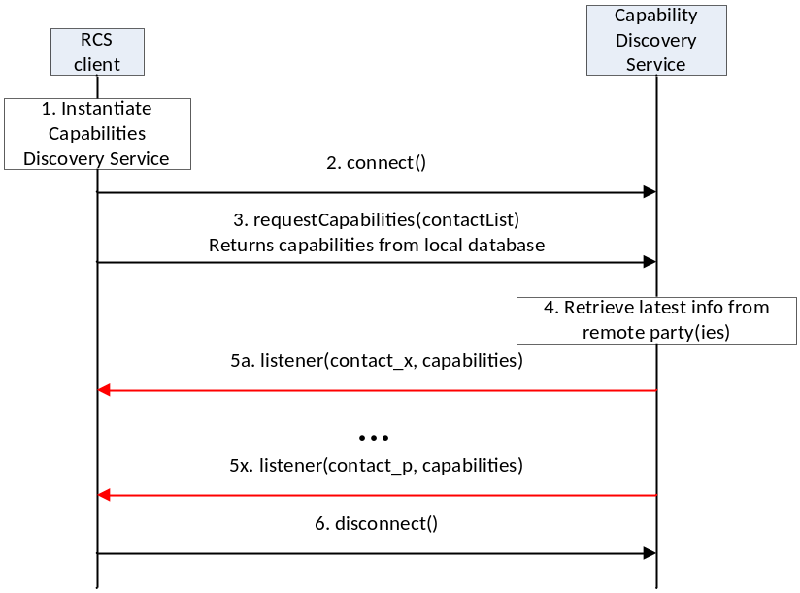

Figure x.x-1: Get the capabilities of a list of remote contacts

- The RCS client instantiates a service instance of the Capability Discovery Service. At this time, it also specifies the list of listener functions.
- The RCS client establishes a connection with the Capability Discovery Service. The Capability Discovery Service associates the listener with this RCS client.
- The RCS client constructs a list of contacts for which it wants to get the latest capabilities. It invokes the API to get the capabilities of these contacts by providing the contact list as argument. The Capability Discovery Service returns the requested information from the local database.
- Additionally, the Capability Discovery Service initiates procedures with the remote parties to retrieve the latest capabilities.
- When the updated capability information is available for a contact, the listener function(s) are invoked to inform all the RCS clients that have installed a listener. This step is repeated for each contact for which updated capability information becomes available.
- Finally, the RCS client, having retrieved the contact information, disconnects from the capability discovery service. At this time, the Capability Service discards all listeners associated with this client.

4.4.4.2 Package
Package name org.gsma.joyn.capability

4.4.4.3 Methods and Callbacks
Class CapabilityService:
This class offers the main entry point to the Capability service which permits to read capabilities of remote contacts, to initiate capability discovery and to receive capabilities updates. Several applications may connect/disconnect to the API.
A set of capabilities is associated to each MSISDN of a contact.

Method: connects to the API.
void connect()

Method: disconnects from the API.
void disconnect()

Method: returns the capabilities supported by the local end user. The supported capabilities are fixed by the MNO and read during the provisioning.
Capabilities getMyCapabilities()

Method: returns the capabilities of a given contact from the local database. This method doesn’t request any network update to the remote contact. The parameter contact supports the following formats: MSISDN in national or international format, SIP address, SIP-URI or Tel-URI.
Capabilities getContactCapabilities(String contact)

Method: requests capabilities to a remote contact. This method initiates in background a new capability request to the remote contact by sending a SIP OPTIONS. The result of the capability request is sent asynchronously via callback method of the capabilities listener. A capability resfresh is only sent if the timestamp associated to the capability has expired (the expiration value is fixed via MNO provisioning). The parameter contact supports the following formats: MSISDN in national or international format, SIP address, SIP-URI or Tel-URI. If the format of the contact is not supported an exception is thrown. The result of the capability refresh request is provided to all the clients that have registered the listener for this event.
void requestContactCapabilities(String contact)

Method: requests capabilities for a group of remote contacts. This method initiates in background new capability requests to the remote contact by sending a SIP OPTIONS. The result of the capability request is sent asynchronously via callback method of the capabilities listener. A capability resfresh is only sent if the timestamp associated to the capability has expired (the expiration value is fixed via MNO provisioning). The parameter contact supports the following formats: MSISDN in national or international format, SIP address, SIP-URI or Tel-URI. If the format of the contact is not supported an exception is thrown. The result of the capability refresh request is provided to all the clients that have registered the listener for this event.
void requestContactCapabilities(Set<String> contacts)

Method: requests capabilities for all contacts existing in the local address book. This method initiates in background new capability requests for each contact of the address book by sending SIP OPTIONS. The result of a capability request is sent asynchronously via callback method of the capabilities listener. A capability resfresh is only sent if the timestamp associated to the capability has expired (the expiration value is fixed via MNO provisioning). The result of the capability refresh request is provided to all the clients that have registered the listener for this event.
void requestAllContactsCapabilities()

Method: registers a listener for receiving capabilities on any contact.
void addCapabilitiesListener(ICapabilitiesListener listener);

Method: unregisters a capabilities listener.
void removeCapabilitiesListener(ICapabilitiesListener listener);

Method: registers a capabilities listener for receiving capabilities on a list of contacts.
void addCapabilitiesListener(Set<String> contacts, ICapabilitiesListener listener);

Method: unregisters a capabilities listener on a list of contacts.
void removeCapabilitiesListener(Set<String> contacts, ICapabilitiesListener listener);

Class ICapabilitiesListener:
This class offers callback methods for the listener of capabilities.

Method: callback called when new capabilities are received for a given contact. The first argument contact contains the canonical representation of the identity of the contact whose capabilities are indicated by the second argument capabilities.
void onCapabilitiesReceived(String contact, Capabilities capabilities)

Class Capabilities:
This class encapsulates the different capabilities which may be supported by the local user or a remote contact.

Method: returns true if file transfer is supported, else returns false
boolean isFileTransferSupported()

Method: returns true if IM/Chat is supported, else returns false
boolean isImSessionSupported()

Method: returns true if image sharing is supported, else returns false
boolean isImageSharingSupported()

Method: returns true if video sharing is supported, else returns false
boolean isVideoSharingSupported()

Method: returns true if geolocation push is supported, else returns false
boolean isGeolocPushSupported()

Method: returns true if IP voice call is supported, else returns false
boolean isIpVoiceCallSupported()

Method: returns true if IP video call is supported, else returns false
boolean isIpVideoCallSupported()

Method: returns true if the specified feature tag is supported, else returns false. The parameter tag represents the feature tag to be tested.
boolean isExtensionSupported(String tag)

Method: returns the list of supported RCS extensions
Set<String> getSupportedExtensions()

4.4.4.4 Content Providers
A content provider is used to store locally the capabilities of each remote contact. In this case the capabilities may be read even if there is no connection to the RCS platform. There is one entry per remote MSISDN.

The content provider has the following columns:
Data | Data type | Comment
CONTACT_NUMBER | TEXT | Contains the MSISDN of the contact associated to the capabilities
CAPABILITY_IMAGE_SHARING | Integer | Image sharing capability. Values: 1 (true), 0 (false)
CAPABILITY_VIDEO_SHARING | Integer | Video sharing capability. Values: 1 (true), 0 (false)
CAPABILITY_IM_SESSION | Integer | IM/Chat capability. Values: 1 (true), 0 (false)
CAPABILITY_FILE_TRANSFER | Integer | File transfer capability. Values: 1 (true), 0 (false)
CAPABILITY_GEOLOC_PUSH | Integer | Geolocation push capability. Values: 1 (true), 0 (false)
CAPABILITY_IP_VOICE_CALL | Integer | IP voice call capability. Values: 1 (true), 0 (false)
CAPABILITY_IP_VIDEO_CALL | Integer | IP video call capability. Values: 1 (true), 0 (false)
CAPABILITY_EXTENSIONS | TEXT | Supported RCS extensions. List of features tags semicolon separated (e.g. <TAG1>;<TAG2>;…;TAGn)

4.4.4.5 RCS extensions
A MNO/OEM application can create a new RCS/IMS service by defining a new RCS capability (or RCS extension. This new service is identified by a feature tag which is the unique key to identify the service in the RCS API and to trigger the service internally in the device and to route the service in the network side. Then the new feature tag will be also used by the IMS API in order to implement the service.
To create a new capability, the MNO/OEM application should declare the new supported feature tag in its Android Manifest file. Then, when the MNO/OEM application is deployed on the device, the RCS service will detect automatically the new installed application and will take into account the new feature tag in the next capability refreshes via SIP OPTIONS.
When the MNO/OEM application is removed the RCS service will remove the associated capability from the next capability refreshes via SIP OPTIONS.
The role of the RCS service is to manage the extensions and to decide to take into account the new feature tag or not. This may be done by analyzing the certificate of the application supporting the feature tag or by checking the provisioning.

4.4.4.5.1 MNO/OEM extension
A MNO/OEM extension starts with the prefix « +g.3gpp.iari-ref=”urn%3Aurn-7%3A3gpp-application.ims.iari.rcse.xxx.yyy », where « xxx » is the MNO/OEM id and « yyy » is an id associated to the application implementing the RCS extension.
See the following API syntax to be added in the Android Manifest file:
<intent-filter>
<action android:name="org.gsma.joyn.capability.EXTENSION"/>
<data android:mimeType="+g.3gpp.iari-ref/urn%3Aurn-7%3A3gpp-application.ims.iari.rcse.xxx.yyy"/>
</intent-filter>

Samples:

Tic Tac Toe game:
<application android:label="Tic Tac Toe">
<activity android:name=".Main">
<intent-filter>
<action android:name="org.gsma.joyn.capability.EXTENSION"/>
<data android:mimeType="+g.3gpp.iari-ref/urn%3Aurn-7%3A3gpp-application.ims.iari.rcse.orange.tictactoe"/>
</intent-filter>
</activity>

IP voice call application:
<application android:label="VoLTE">
<activity android:name=".Main">
<intent-filter>
<action android:name="org.gsma.joyn.capability.EXTENSION"/>
<data android:mimeType="+g.3gpp.icsi-ref/urn%3Aurn-7%3A3gpp-service.ims.icsi.mmtel"/>
</intent-filter>
</activity>

4.4.4.6 Permissions
Access to the Capabilities API is requires the following permissions:

org.gsma.joyn.RCS_READ_CAPABILITIES: this is a new permission that governs access to capability information.

android.permission.READ_CONTACTS: this permission is required by any client using the capabilities service, since use of the API implicitly reveals information about past and current contacts for the device.

======================= End of changes==================================

